**Introduction About College:**

*MVM College was established in the year 1963 By Shri Jalaram Uchch*

*Keravani Mandal. It is the oldest institution in women education in*

*saurashtra for the history of 41 years.*

***Specialization of college:***

* *Special work environment*
* *Educated faculty*
* *Good library facility*
* *Extra practical timing*
* *Competitive work environment*
* *Latest infrastructure*

*The college gives full time for laboratory, useful materials, reference*

*books, and also provide News Papers and Magazines.*

*My college also organizes events like quiz competition, annual*

*functions , sports day and many other activities.*

**Introduction About Project:**

Our site contains much information and tips for the antique collector

in indentifying and selecting quality antique arts.

We offer a lot of well researched information on Antique and

Collectible items, like clay art, pencil art, paper art, rangoli art, sand art.

This site is meant for people who likes purchasing antique arts and

increase their collection in antique arts. Art Gallery have a place in the

heart of each one of us.

***System Development Life Cycle(SDLC):***

*The System Development Life Cycle method is classically through of as the set of activities. The Analysts, designer and users carry out to develop and implement an information system. This method consists of six steps. In most business situations the activities are all closely related. Usually inseparable and even the order of the steps in these activities may be difficult to determine. Different parts of the project can be in various phases at the same time, with some components undergoing analysis while others are at advanced design stages.*

*The System Development Life Cycle model was developed as a structured approach to information system development that guides all the processes involved from an initial feasibility study through to maintenance of the finished application. SDLC models take a variety of approaches to development.*

***Feasibility study:-***

*The feasibility study determine whether the software is Economically, Technically, Operationally & Legally feasible*.

* ***Economical feasible***

*means software is capable to return benificial cost*.

* ***Technically feasible***

*means a study of function,performance that may affect the ability to achieve and acceptable system.*

* ***Operationally feasible***

*means software is capable to consist all the features , which is create software to functionally powerful*.

* ***Legally feasible***

*means a determination of any infringement , violation or liability that could result from development of the system.*

***Requirement Analysis:-***

*Requirement is study the current business to find how it can be*

*work and where should it be improved.*

*Requirement should be always include in new system. This may be processing of data producing information controlling a business activity etc.*

***Requirement of Computerization:***

*Computer technology has provided beneficial in many ways, from*

*visible to invisible, spectacular to routine. Now a days there may not be any*

*place where the computer will not be there to help the great human being.*

*Computer has made the routine work so easy, comfortable and fast that it*

*has totally changed the life of the common human being.*

*It is also use to provide a high-performance system that works much*

*faster as compared to the current manual system.*

*Introduction About PHP:*

* ***Introduction to PHP :***
  + *The fullform of PHP is “Hype-text Preprocessor” or “Personal Home Page”.*
  + *Resums Lerdof software engineer , Apache team member is the creator and original driving force behind PHP. The first part of PHP was developed for his personal use in late 1994.*
  + *By the middle of 1997 , PHP was being used on approximately 50,000 sites worldwide.*
  + *PHP is server-side scripting language , which can be embedded in HTML or used as a stand-alone.*
  + *PHP doesn’t do anything about what a page looks and sounds like . In fact , most of what PHP does is invisible to the end user.*
  + *Someone looking at a PHP page will not necessarily be able to tell it was not written purely in HTML , because usually the result of PHP is HTML.*
  + *PHP is an official module of Apache HTTP server.*
  + *PHP is fully cross – platform , meaning it runs native on several flavors of unix , as well as on Windows and now MacOS .*

***Advantages of PHP :-***

* ***Cost :***

*PHP costs you nothing . It is open source software*

*and doesn’t need to purchase it for development.*

* + ***Ease Of Use :***

*PHP is easy to learn , compared to the others. A lot*

*of Ready-made PHP scripts are freely available in*

*market**so , you can use them in your project or get*

*some help from them.*

* + ***HTML – Support :***

*PHP is embedded within HTML ; In other words , PHP*

*pages are ordinary HTML pages that escape into*

*PHP mode only when a client requests this page ,*

*the web server preprocesses it. This means it goes*

*throught the page from top to bottom , looking for*

*sections of PHP , which it will try to resolve.*

* ***Cross-platform compatibility :***

*MySQL run native on every popular flavor of unix*

*and windows. A huge percentage PHP and of the*

*world’s HTTP servers run on one of these two*

*classes of operating system.**Apache HTTP server for*

*unix and windows, Microsoft internet information server,*

*and Netscape Enterprise server .*

* ***Stability :***

*The word stable means two different things in this*

*context :*

* + - *The server doesn’t need to be rebooted often .*
    - *The software doesn’t change redically and incompatibly*

*from release to release..*

* + ***Speed :***

*PHP is pleasingly zippy in its execution , especially*

*when compiled as and Apache module on the Unix*

*side Althought it takes a slight performance hit by*

*being interpreted rather than compiled , this is far*

*outweighed by the benefits PHP drives from its*

*status as a Web server module.*

***Introduction About Backend(SQL) :***

* + *MySQL , the most popular open source SQL database*

*management system , is developed , distributed , and supported*

*by MySQL .*

* + *MySQL is a commercial company , founded by the*

*MySQL developers . It is a second generation open source*

*company that unites open source values and methodology*

*with a successful business model.*

* + *The official way to pronounce “MySQL” is “My*

*EssQue Ell” (not ‘my sequel’) , but we don’t mind if you*

*pronounce it as “my sequel” or in some other localized*

*way.*

* ***MySQL Features :-***
  + *MySQL is a relational database management system.*
  + *MySQL software is open source.*
  + *The MySQL database server is very fast , reliable , and easy to use.*
* *MySQL server works in client/server or embedded systems*

*Introduction About Supporting Tools:*

###### *HTML :*

###### *HTML was originated by Tim Bernrers-Lee.*

* *HTML developed a few years ago as a subset of SGML (Standard*

*Generalized Markup Language), which is a higher-level markup*

*language that has long been a favorite of the department of defense.*

* *Any HTML document is also valid for SGML.*
* *HTML is a Hyper Text Markup Language that is used to develop*

*web pages.*

* *It is a cross platform markup language that is design to be flexible*

*enough to display text or other elements like graphical in a variety*

*of views.*

* *The HTML document consists of special tags that are embedded in*

*as ASCII document.*

* *Web browser like Internet Explorer, Netscape Navigator etc.*

*interprets these Tags.*

* *HTML document file extension is ‘. Html’ OR ‘. Htm’*
* ***JavaScript :***
  + *JavaScript was designed to add interactivity to HTML pages.*
  + *JavaScript is a scripting language (a scripting language is a*

*lightweight programming language).*

* + *A JavaScript consists of lines of executable computer code.*
  + *A JavaScript is usually embedded directly into HTML pages.*
  + *JavaScript is an interpreted language (means that scripts*

*execute without preliminary compilation).*

* *Everyone can use JavaScript without purchasing a license.*
* ***Likno Web Button Maker:***
* *It is use to make a different types of button and that buttons are*

*used as a link of the web site.*

* *It provides many properties like button shape,background,button*

*shadow,text,links,dimensions etc.*

* ***SwishMax:***
* *It is use to change the format of the text and different shapes.*
* *It provides many effects which are used to make interactive text and shapes.*

***Software Requirement and Specification:***

* ***Requirement:***
* *128 MB RAM*
* *2 GB Hard Disk*
* ***Software Requirements:***
* *PHP/MySQL*
* *Macromedia DreamWeaver*
* ***Operating System:-***
* *Windows XP*
* ***Specification:-***

*The data which is collected during the investigation using the fact finding technique is analyzed to determine requirement specification.It consist of three interrelated part:*

* + *Analysis is of factual data.*
  + *Identification of essential requirement.*
  + *Selection of requirement fulfillment strategies.*

*All these three activities are very important and must be performed*

*Currently*

***Data Dictionary:***

***Login:-***

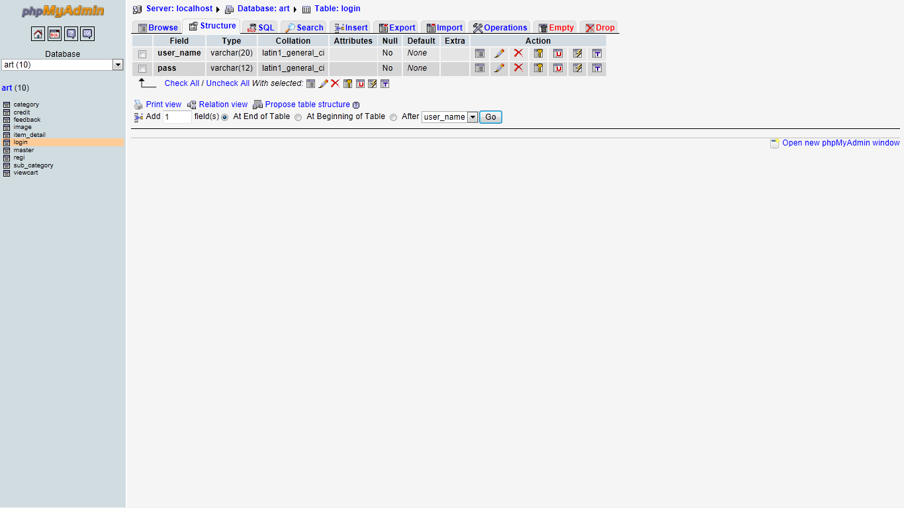

***Registration table:-***

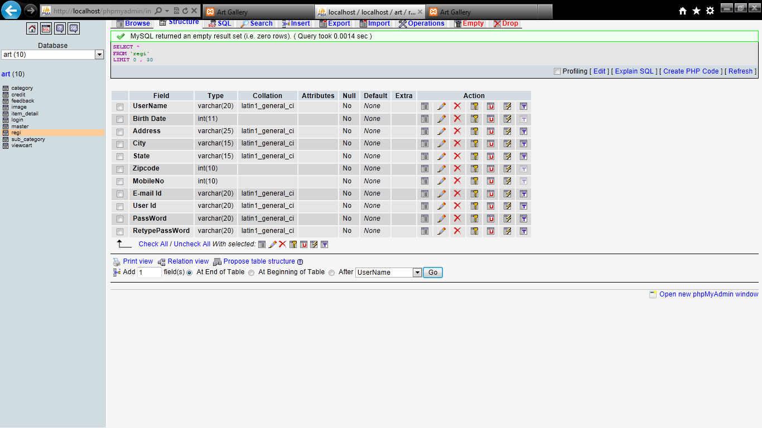

***Item_detail:-***

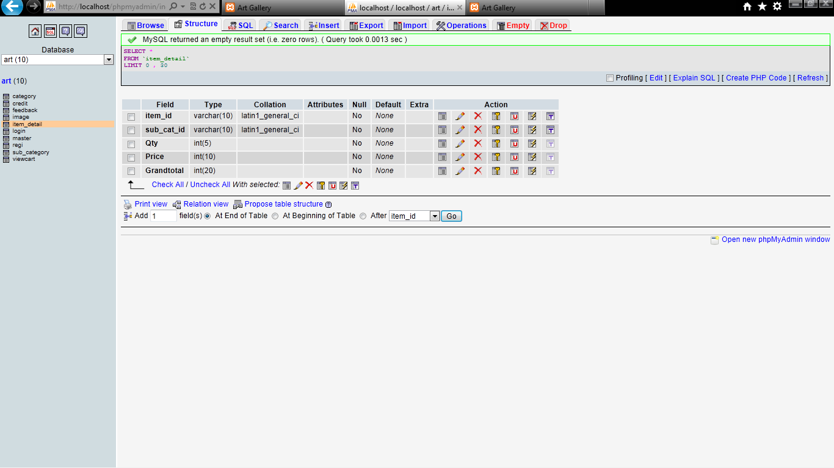

***ViewCart:-***

**

***Feedback:-***

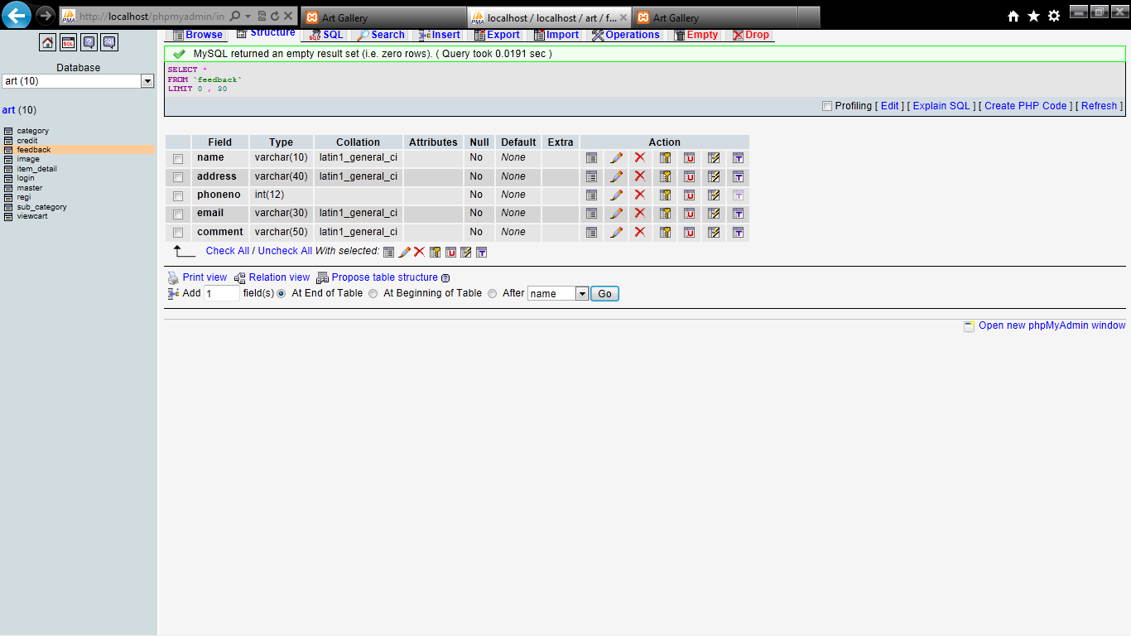

# *Sub Category:-*

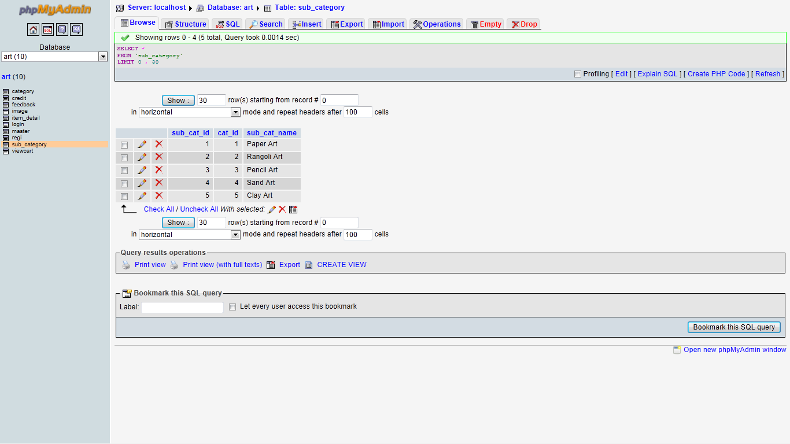

***Image*:-**

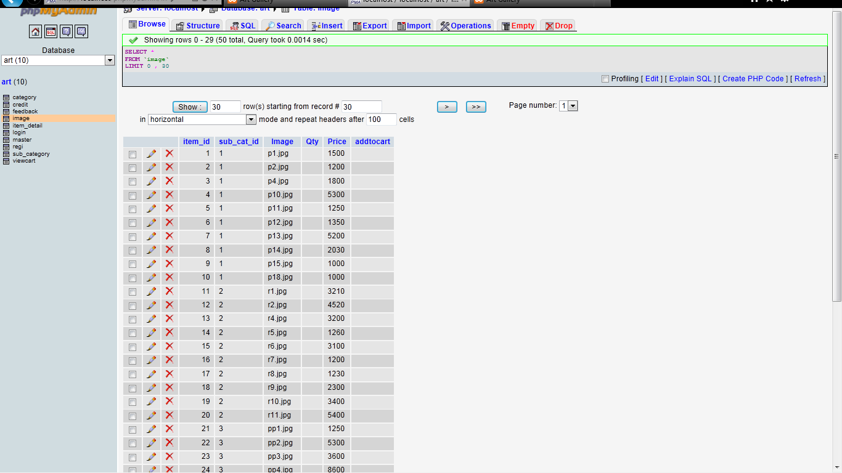

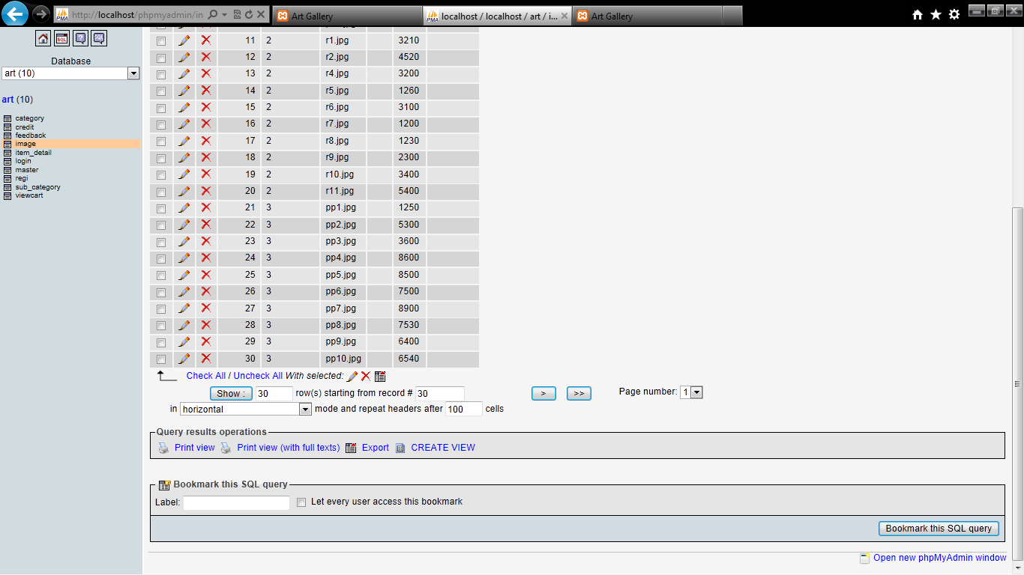

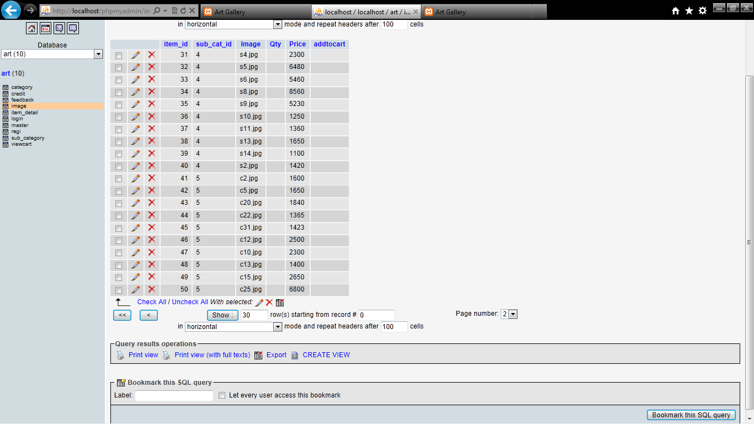

***Data Flow Diagram:-***

*A DFD is a pratical representation of the path which data takes from its initial interaction with the system until it completes any interactions. The diagram will describe the logical dataflow without detailing the movement of any data.*

*A DFD doesn’t show a sequence of steps,a DFD only shows what are different process in a system are and what data flow between.*

***SYMBOLS:-***

*A square defines a source of destination*

*An arrow shows the data in motion.*

*A circle represents a process.*

***Data Flow Diagram:-***

*index.php*

*(Home page)*

*Registration.php*

*(Registration page)*

*login .php*

*(login page)*

*home.php*

*(Listing page)*

*Aboutus.php*

*(Informationpage)*

*Gallery.php*

*(links of all products)*

*Addtocart.php*

*(opens the page of which link is selected* )

*Billing page*

*(&log out)*

***E-R Diagram:-***

***ART GALLERY***

***CONTACT US***

***ABOUT US***

***GALLERY***

***LINKS FOR PRODUCTS***

***BILLING***

***Testing tools and Implementation:-***

* *It is functioning application of Development Tools.*
* *The design must be translated into machine readable form.*
* *If design is performed in a detailed manner,code generation can be accomplished mechanistically.*
* *Once code has been generated,program testing begins.*
* *The testing process focuses on the logical internals of the software, assuring*
* *That all statement have been tested and on the functional externals that is uncover errors etc.*
* *A testing library is a set of data developed to thoroughly test a system of programs.*
* *The testing library should be maintained throughout the life of the system so that,as each change is made,reliable data are again available to test the system.*

***Home Page (index.php)***



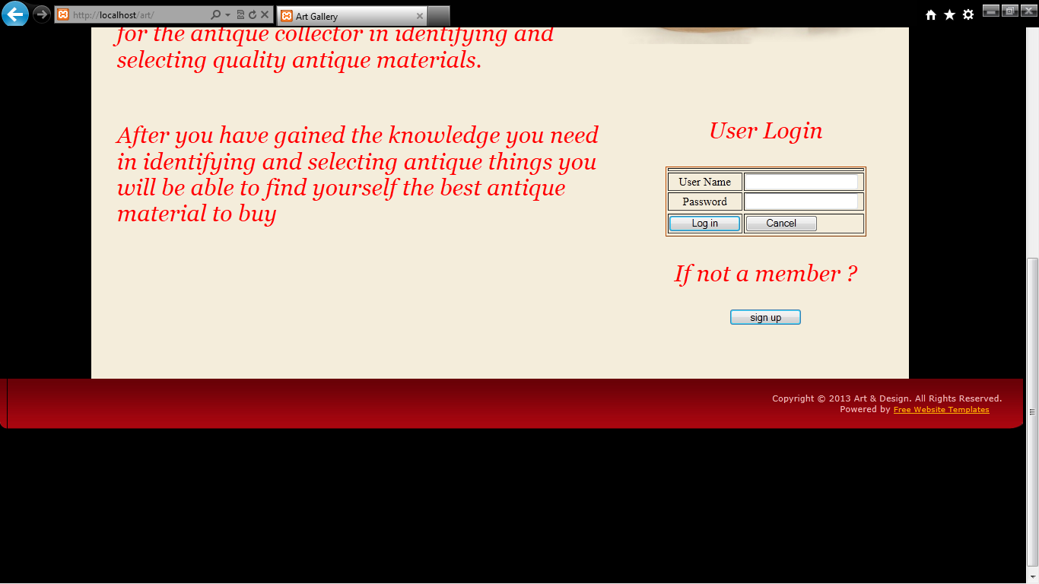

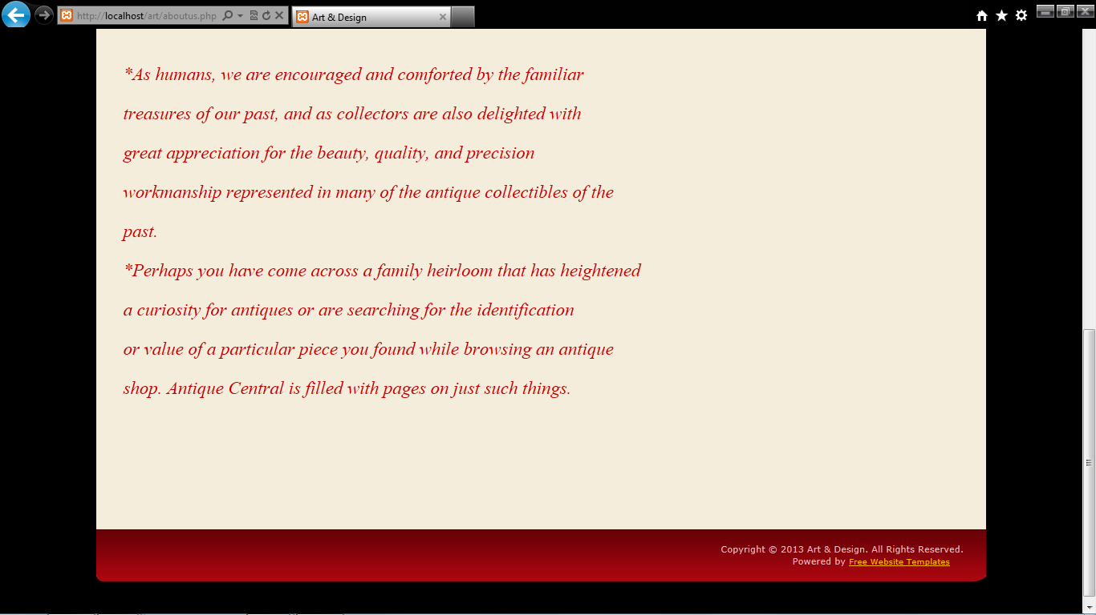

***Registration form(regi.php)***

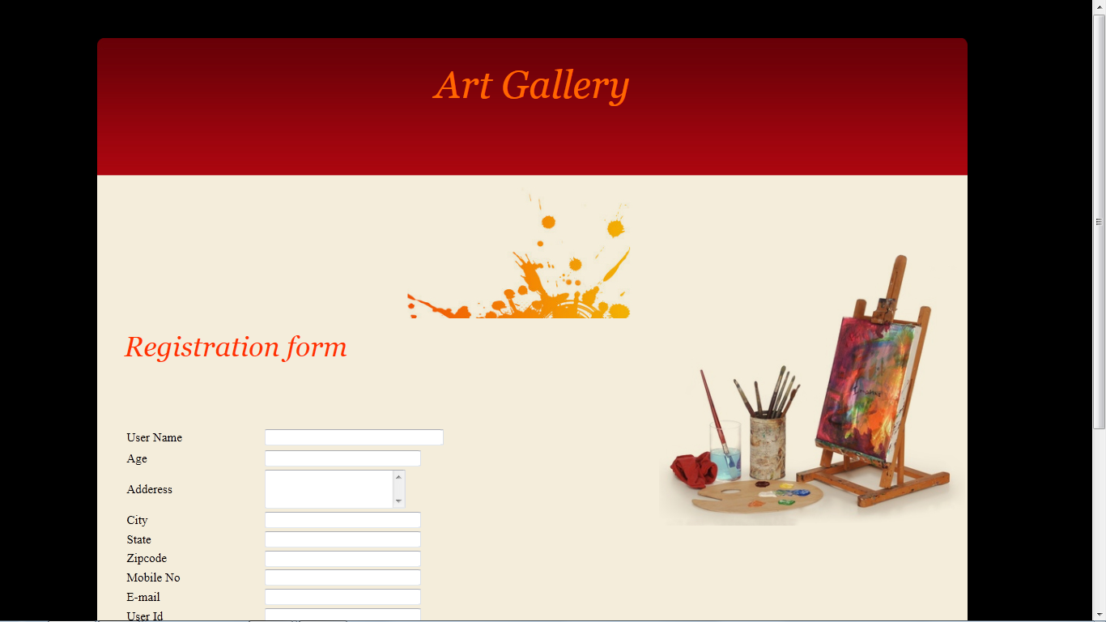

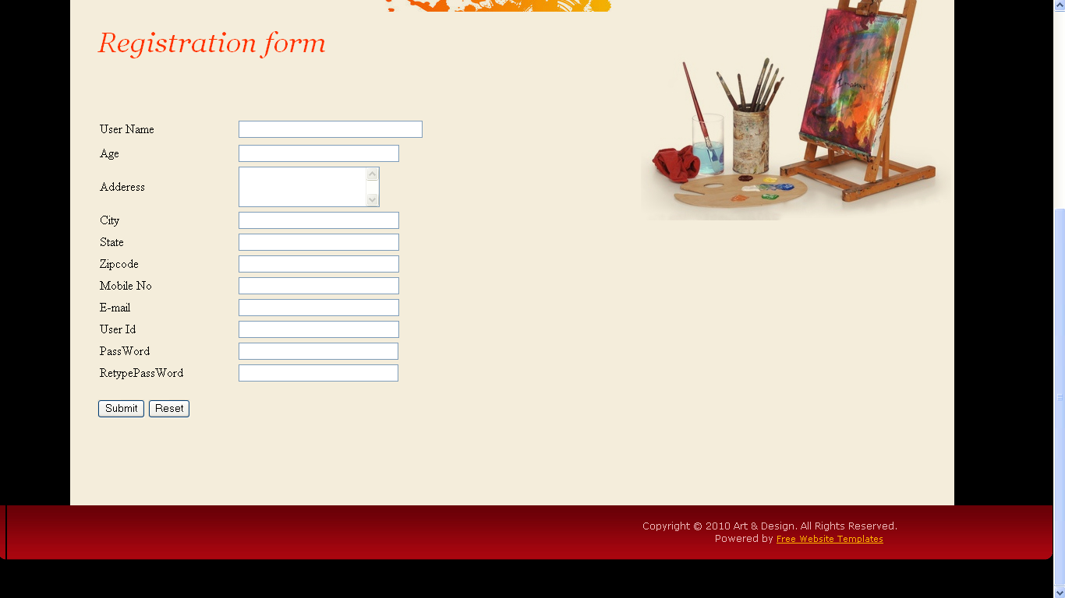

***About us(aboutus.php)***

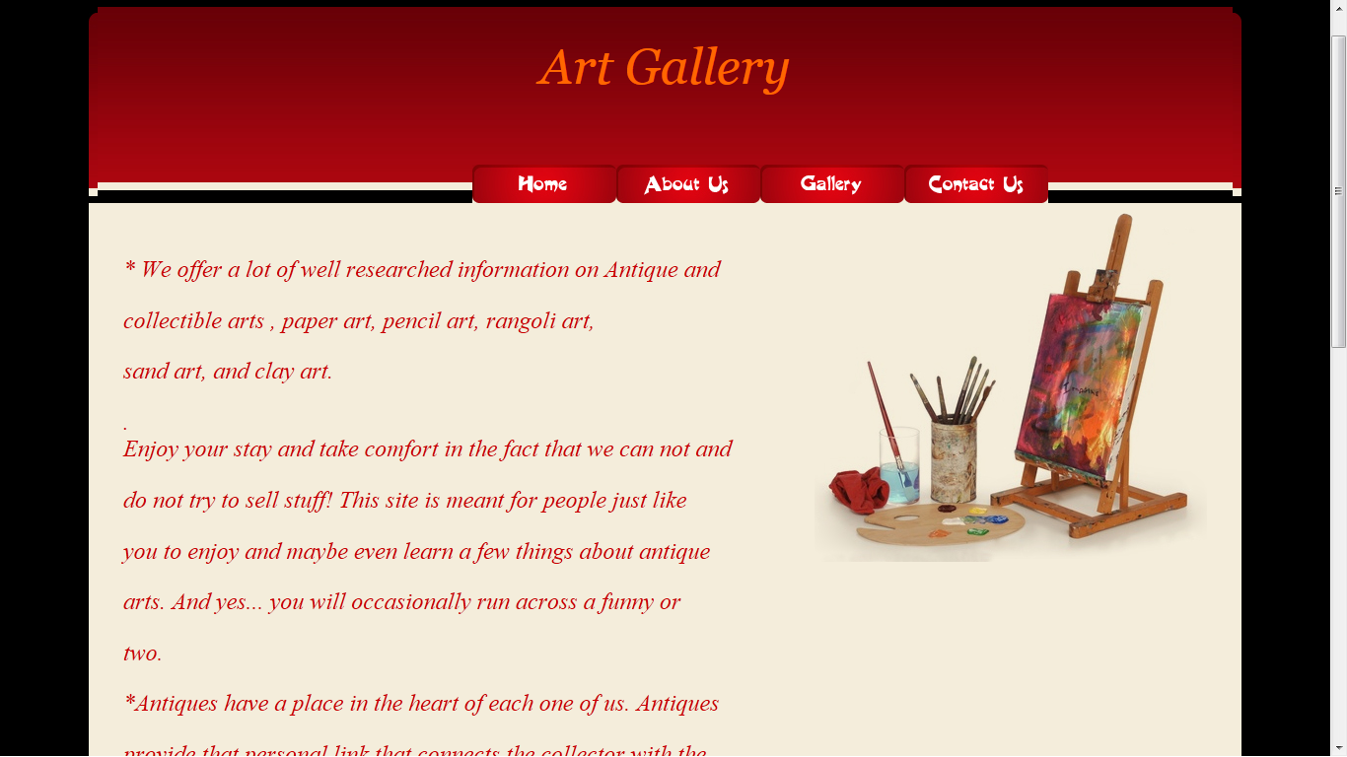

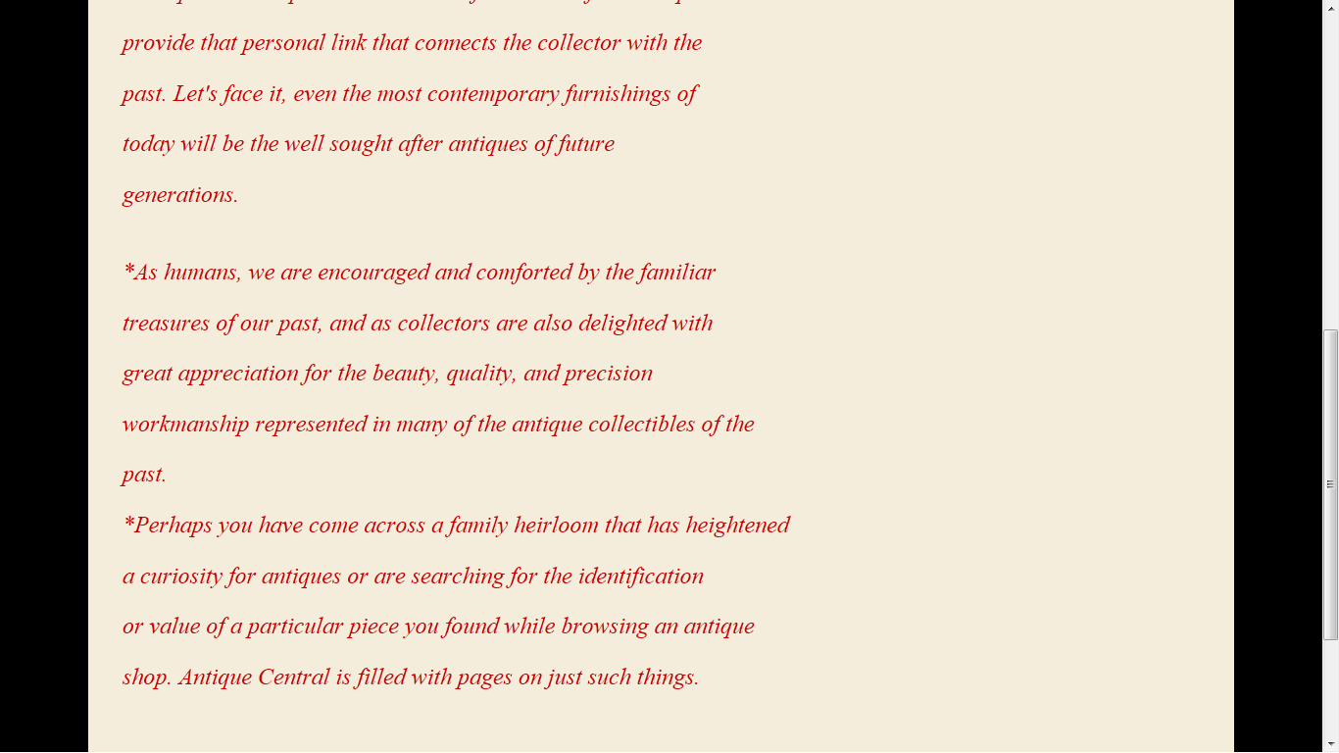

***Gallery (gallery.php)***

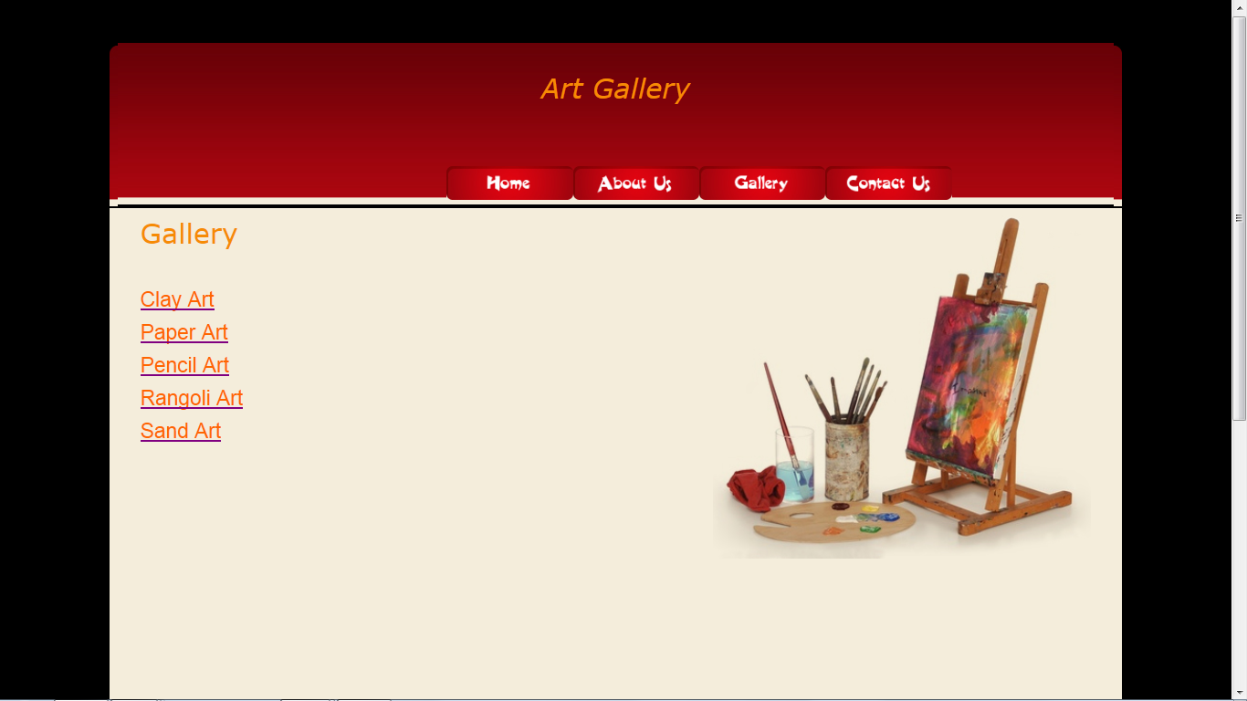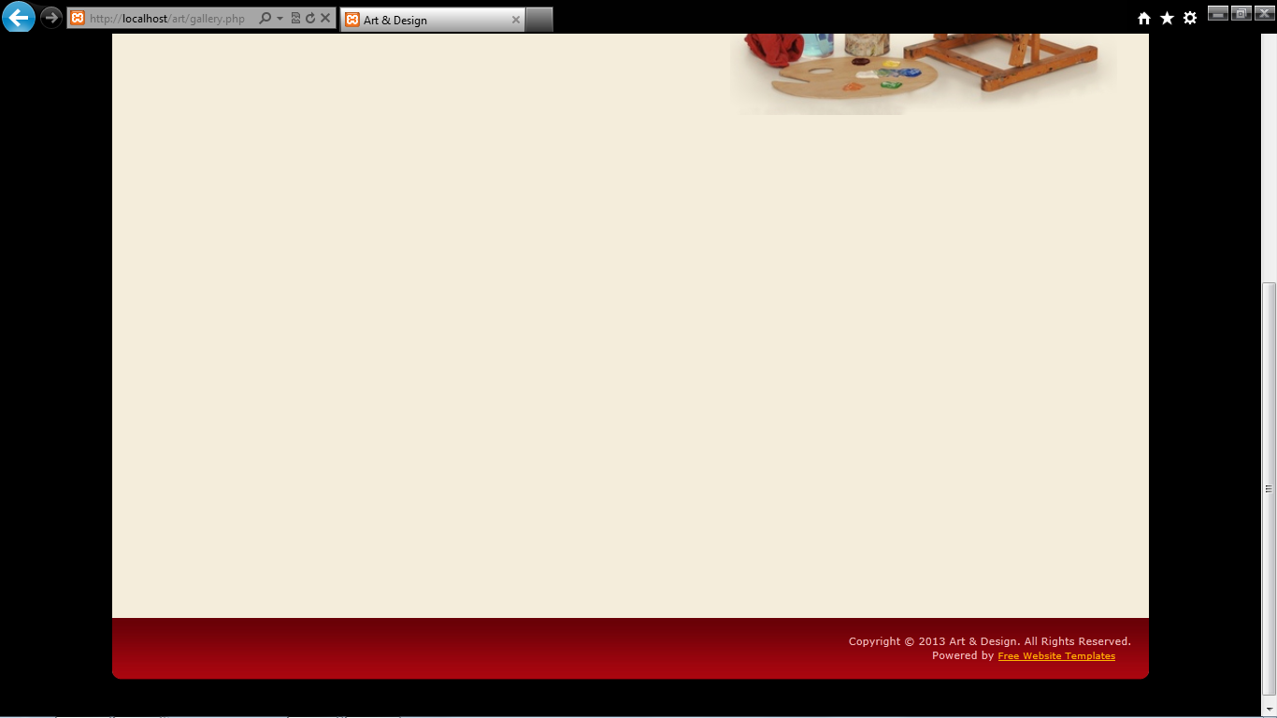

***Add To Cart(addtocart.php)***

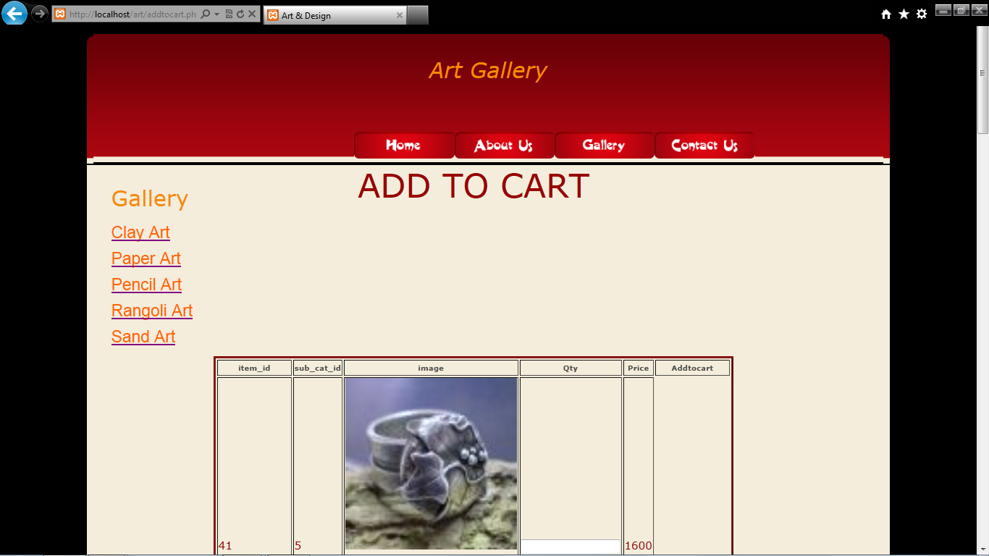

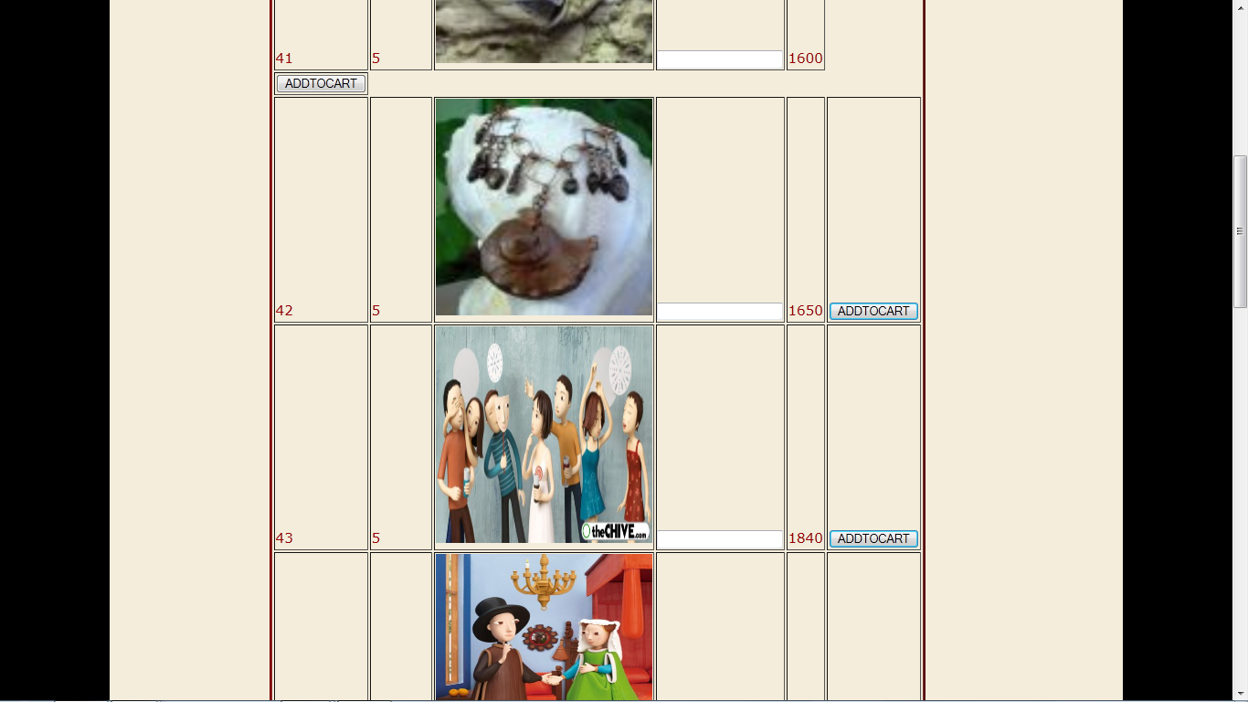

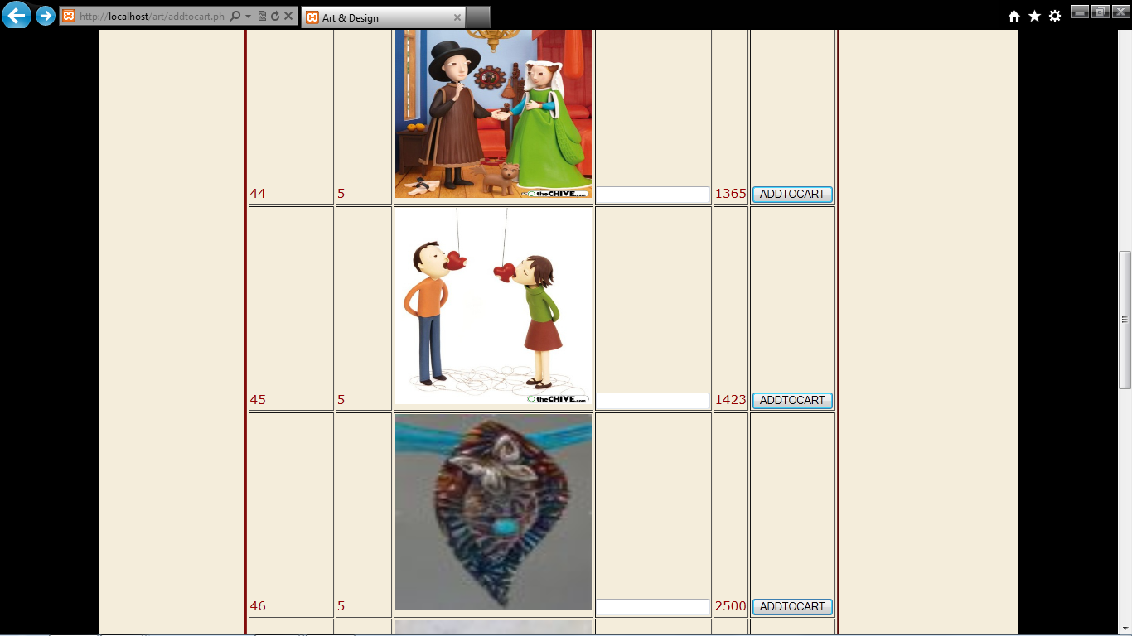

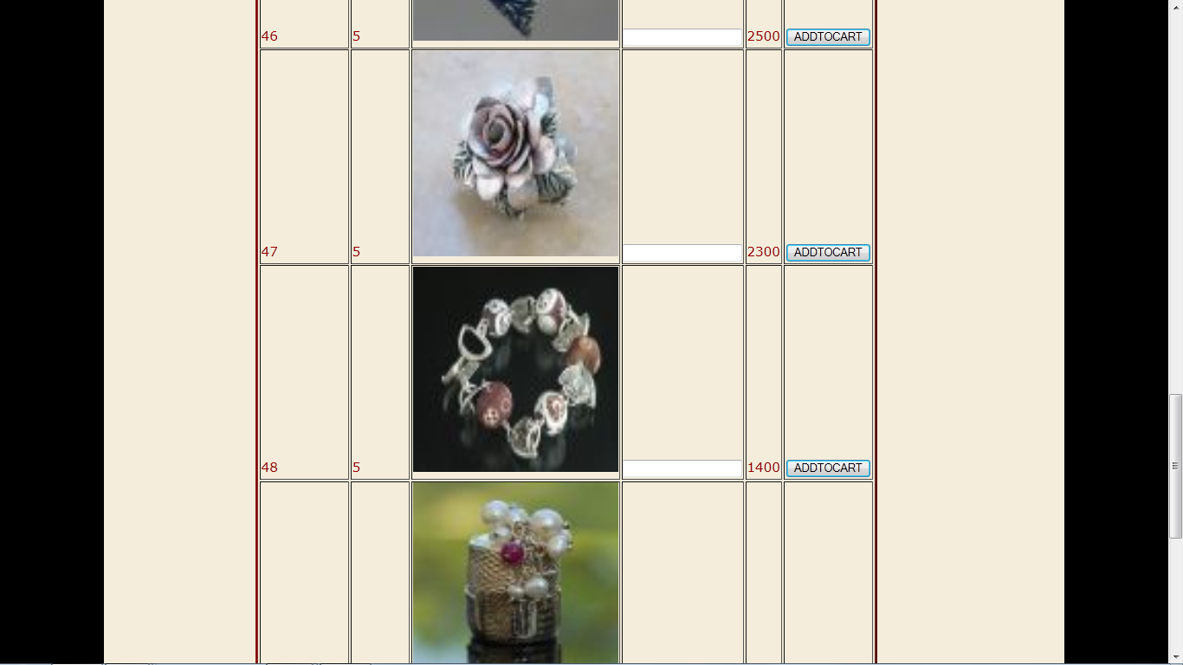

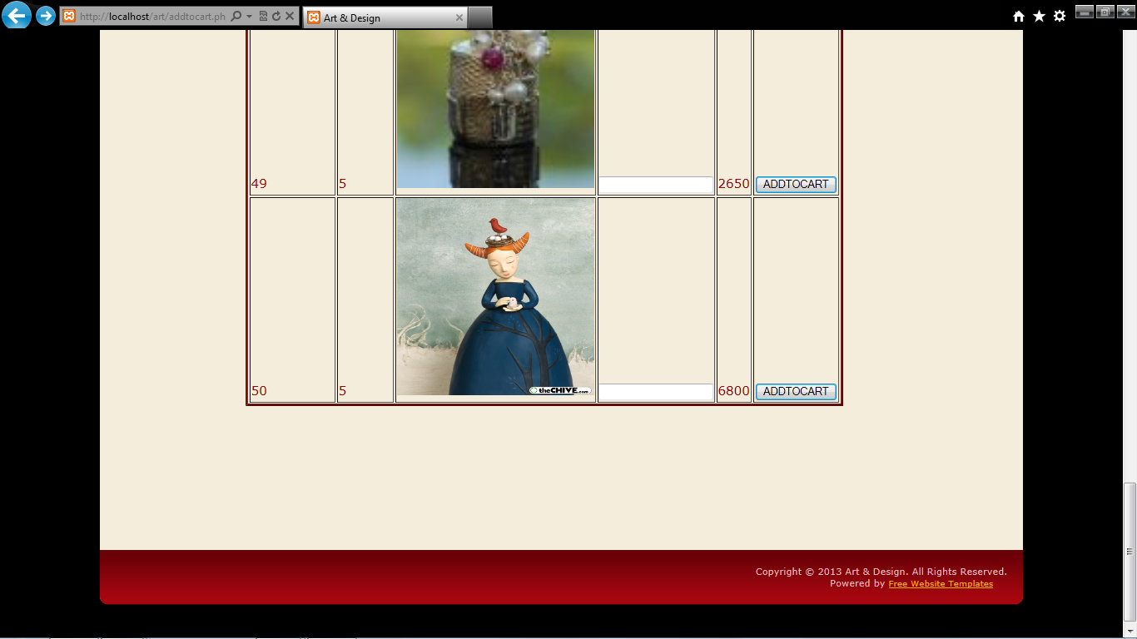

***Contact us(contactus.php)***

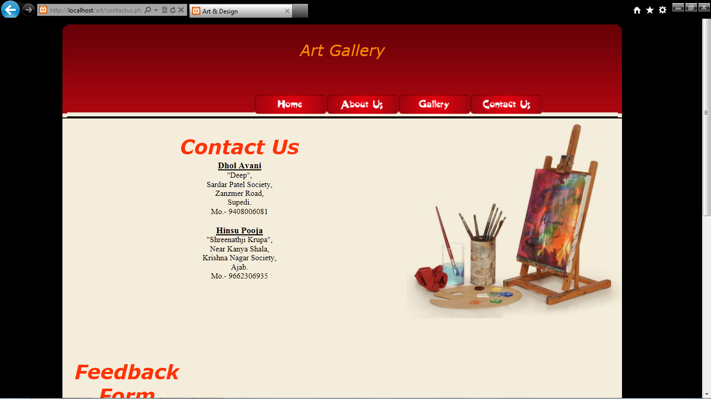

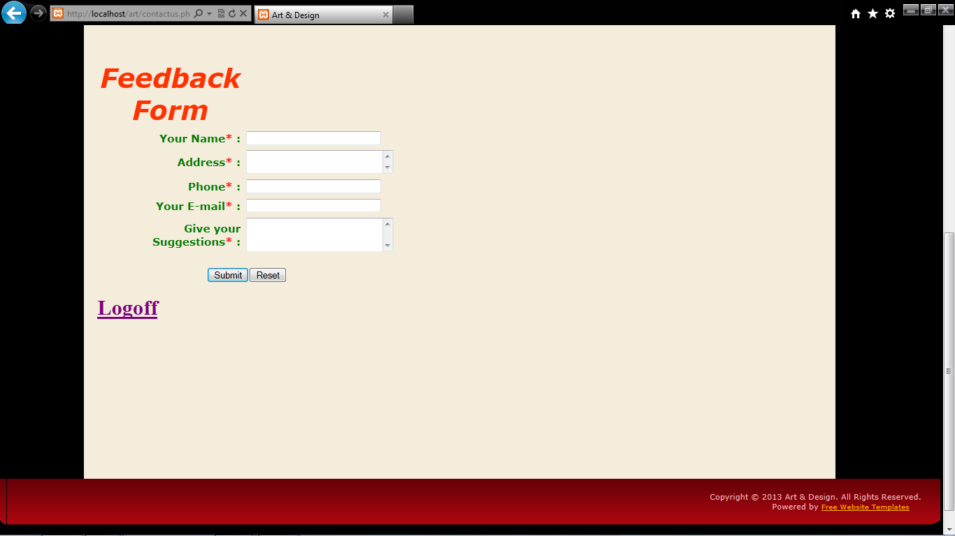

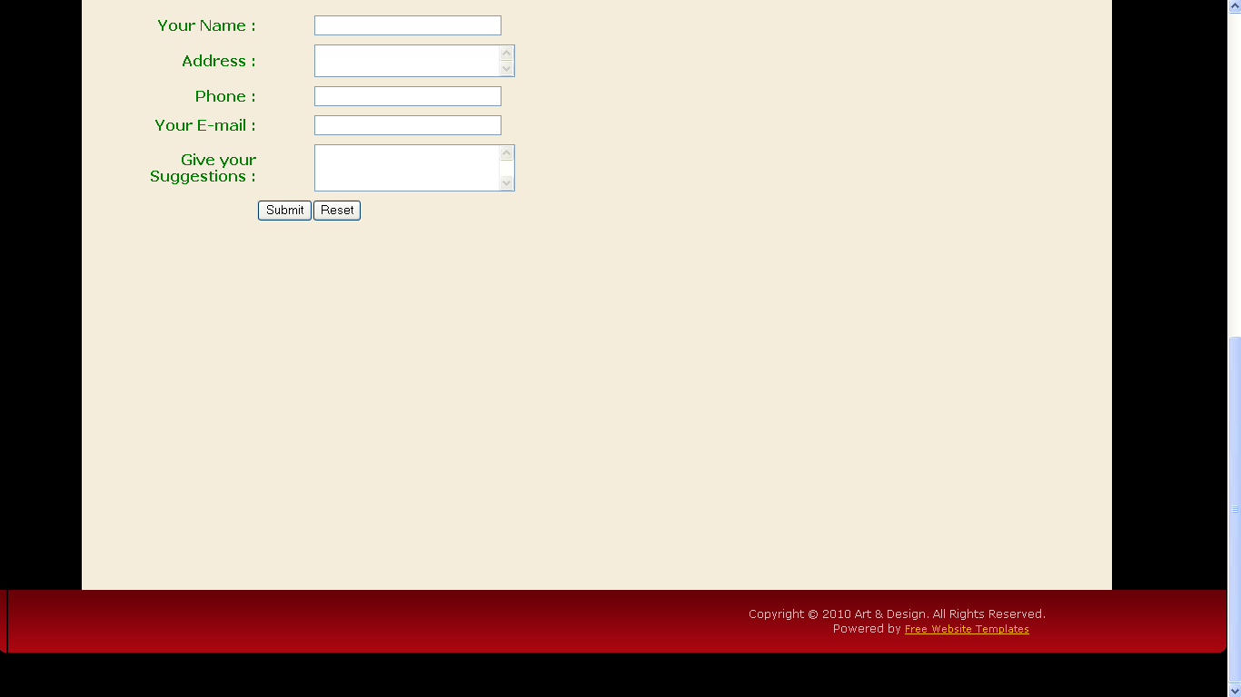

***Admin (admin.php)***

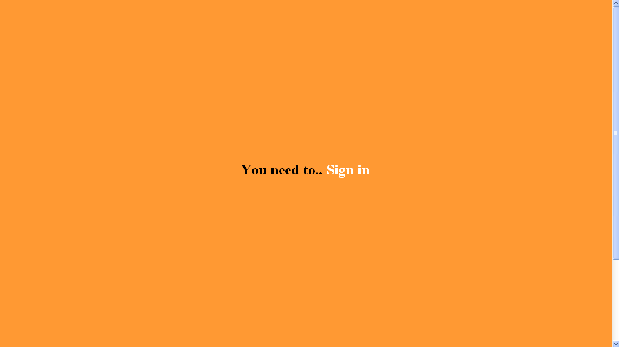

***Administrator login(adminlogin.php)***

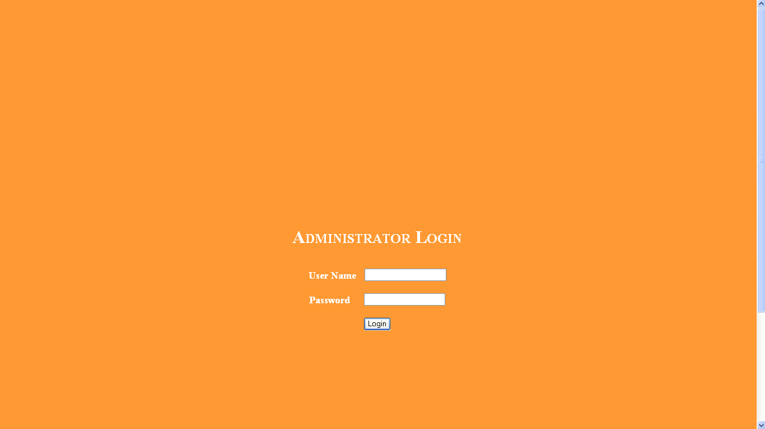

***AddUpdateDelete (addupdatedel.php)***

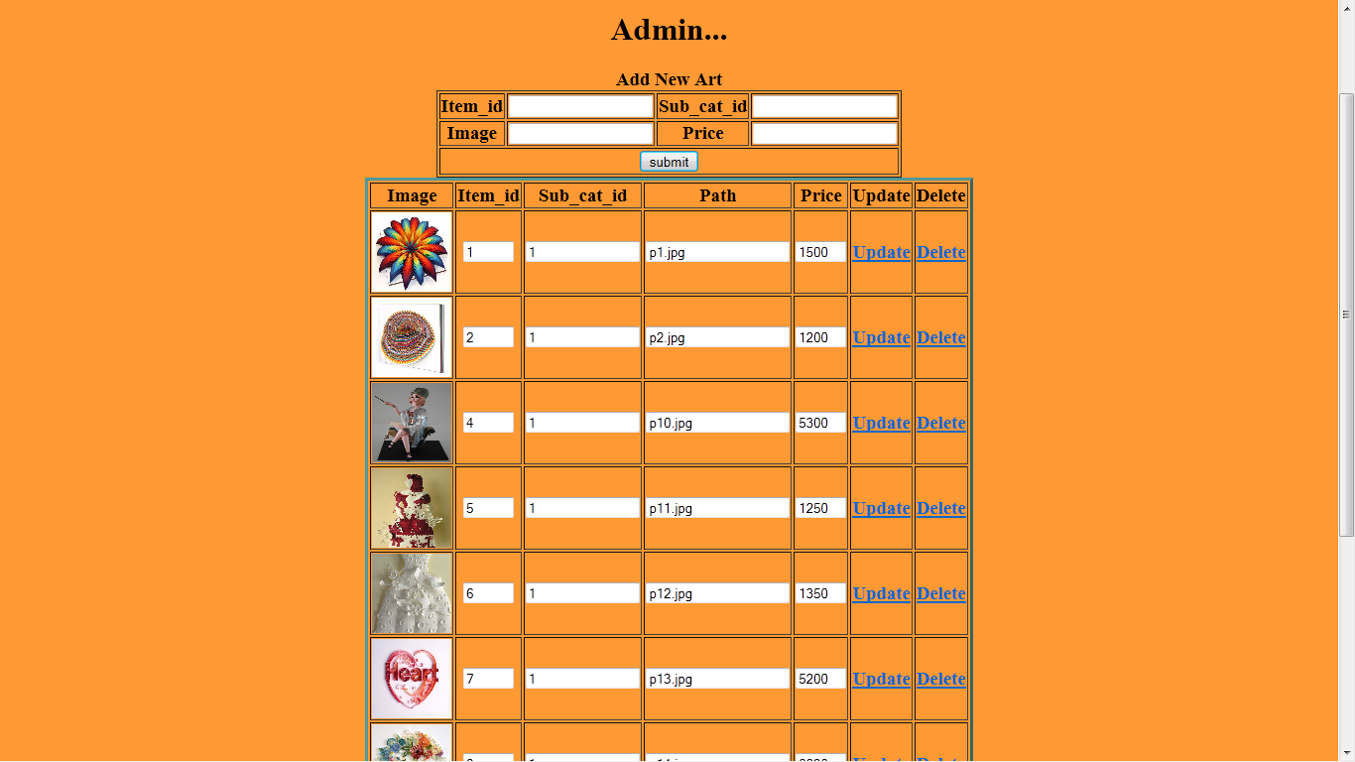

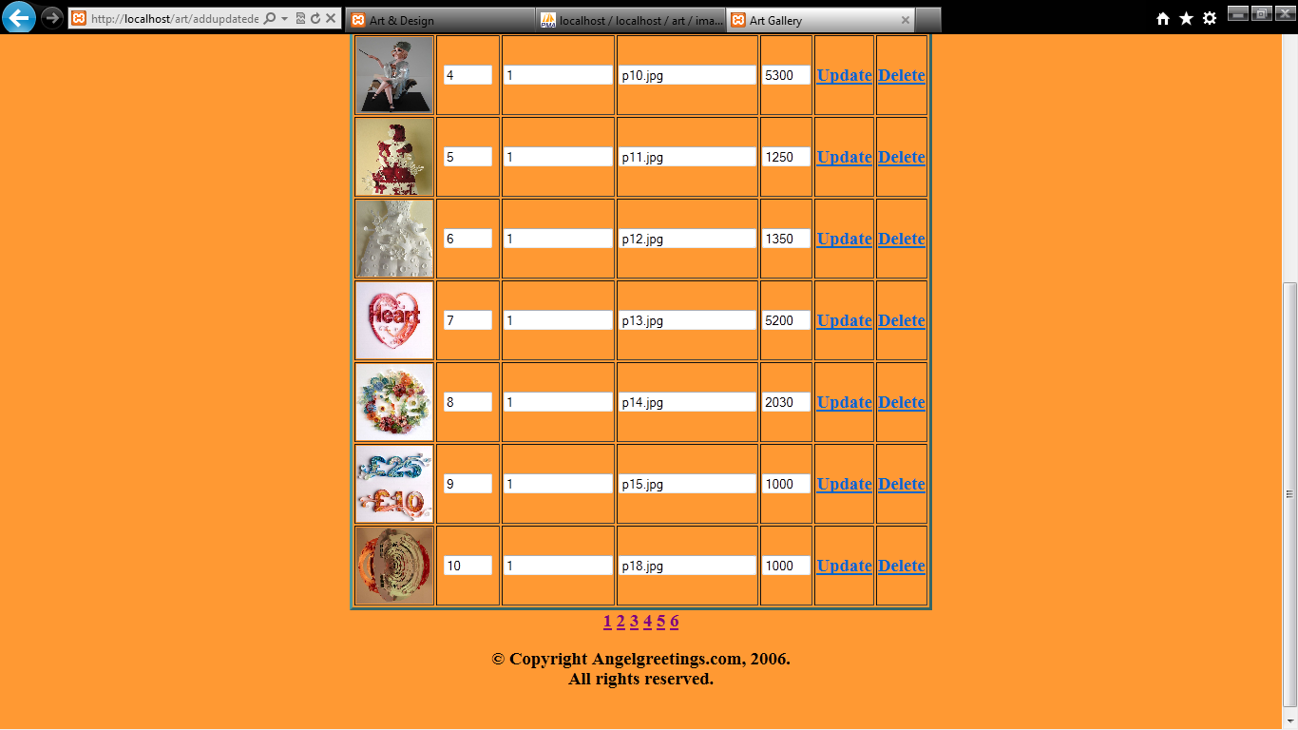

***Achievements:***

*Presently, we have developed our selling of antique*

*collection on small basis.*

*But our future plans is to gather huge antique collection and*

*sell world wide so that the people who loves, buying antique things*

*and who wants to gather antique materials, may get priviledge to*

*buy things.*

*We would even give facility to customers world wide to buy*

*antique materials*

***Limitation:***

* *This project runs only Internet Explorer Browser.*
* *If you run this project,XAMPP must be installed in your computer.*
* *In this project, SwishMax software is used and it requires high RAM So if*

*your computer is not provide high RAM,the process will very slow to display*

*the page that use SwishMax.*

* *The user can download only that type which are listed on download listing*

*page.*

***Bibliography:***

***Books:-***

* *PHP 5.0*
* *Analysis & design of information system*
* *HTML and javascript*

***Websites:-***

* [*www.google.com*](http://www.google.com)
* [*www.mysql.com*](http://www.mysql.com)

***Softwares:-***

* *Macromedia Dreamweaver*
* *Adobe Photoshop CS4*